**To Supply Leftover Food to Poor**

# Project Overview

The "To Supply Leftover Food to Poor" project is an impactful initiative leveraging Salesforce to reduce food waste and address hunger among underprivileged communities. By centralizing the management of food collection points, tasks, volunteers, and drop-off locations, the project efficiently redistributes surplus food from sources like restaurants, events, and households. Task coordination within Salesforce ensures streamlined food collection, quality checks, and delivery, while volunteer management tools foster a dedicated network of helpers. Geolocation features automatically assign drop-off points based on proximity, ensuring food reaches nearby communities quickly. Real-time monitoring and feedback systems allow organizers to track food distribution metrics, optimize resources, and continuously improve service delivery. Through this coordinated effort, Salesforce transforms excess food into a valuable resource for communities in need.

# Objectives

**Business Goals**:

• **Reduce Food Waste**: Decrease the amount of surplus food wasted by 40% within the first year by connecting food donors with nearby communities in need.

• **Expand Community Reach**: Increase the number of underprivileged beneficiaries served by 30% through strategic partnerships with food donors and community organizations.

• **Optimize Volunteer Engagement**: Enhance volunteer involvement by providing clear roles, streamlined communication, and tracking of volunteer impact, leading to improved retention and satisfaction.

• **Promote Operational Efficiency**: Automate key processes to reduce manual work by 50%, allowing for faster food collection and redistribution.

**Specific Outcomes**:



• **Food Redistribution Metrics Dashboard**: Develop a real-time dashboard within Salesforce to monitor food collection, redistribution rates, and waste reduction metrics across locations.

• **Automated Task Assignment**: Set up automated task assignments for volunteers, including collection, sorting, and delivery tasks, to reduce manual coordination.

• **Drop-Off Point Allocation**: Implement geolocation-based drop-off allocation to ensure food is directed to the nearest communities in need, enhancing delivery speed and efficiency.

• **Real-Time Reporting**: Generate monthly reports on key performance indicators (KPIs), such as food volume redistributed, response times, and volunteer hours contributed.

• **Community Feedback System**: Establish a feedback loop where beneficiaries can rate and comment on the quality and timeliness of food deliveries, ensuring continuous improvement.

# Salesforce Key Features and Concepts Utilized

1. **Salesforce CRM**:
   * **Account and Contact Management**: Manage food donors, volunteers, and beneficiary organizations as accounts and contacts for efficient tracking, relationship building, and outreach.
2. **Automation Tools**:
   * **Flow and Process Builder**: Automate key processes, such as task assignment to volunteers, notifications for new food collections, and updating food distribution records.
   * **Workflow Rules and Triggers**: Automate specific actions, such as sending alerts to volunteers for upcoming food pickups or notifying drop-off locations about incoming deliveries.
3. **Data Management and Reporting**:
   * **Reports and Dashboards**: Track and visualize important metrics, such as food collected and distributed, volunteer hours, and reduction in food waste, all in real-time. Dashboards can also highlight high-demand areas to optimize distribution routes.
   * **Data Import Wizard and Data Loader**: Simplify data imports for large volumes of information from external sources, such as new donation points or volunteer information.
4. **Geolocation and Distance-Based Sharing Rules**:
   * **Geolocation Fields**: Geolocation capabilities are used for assigning the nearest drop-off locations to food collection points based on distance.
   * **Sharing Rules**: Distance-based sharing rules segment drop-off points into categories (e.g., under 15 km, 15–30 km, etc.), automatically sharing data with relevant public groups to streamline logistics.
5. **Salesforce Mobile App**:
   * Enable on-the-go access for volunteers, allowing them to view assigned tasks, check drop-off locations, and update task status from their mobile devices, increasing flexibility and responsiveness.
6. **Custom Objects and Relationships**:
   * **Custom Objects**: Define custom objects for "Food Collection Points," "Tasks," "Drop-Off Points," etc., to organize and structure project-specific data.
   * **Relationship Fields**: Link custom objects (e.g., "Drop-Off Points" connected to "Food Collection Points") to create a relational data structure, making it easier to manage interactions and track dependencies.
7. **Community Cloud (if applicable)**:
   * Create a community portal where donors, volunteers, and community members can log in, view their assigned tasks or contributions, and stay updated on food distribution events.
8. **Einstein Analytics (if applicable)**:
   * **AI-Powered Insights**: Predict areas with the highest food demand or identify patterns in food waste reduction, helping to improve resource allocation and forecasting.

# Detailed Steps to Solution Design

**CREATION OF OBJECTS:**

**Create Venue Object:**

To create an object:

1. From the setup page >> Click on Object Manager >> Click on Create >>Click on Custom Object.
2. Enter the label name >> Venue
3. Plural label name >> Venues
4. Enter Record Name Label and Format

* Record Name >> Venue Name
* Data Type >> Text

1. Click on Allow reports and Track Field History,Allow Activities.
2. Allow search >> Save.

**Create Drop-Off Point Object**

To create an object:

1. From the setup page >> Click on Object Manager >> Click on Create >> Click on Custom Object.
2. Enter the label name >> Drop-Off Point
3. Plural label name>> Drop-Off Points
4. Enter Record Name Label and Format

* Record Name >> Drop-Off point Name
* Data Type >> Text

Click on Allow reports and Track Field History,Allow Activities

Allow search >> Save.

**Create Task Object:**

To create an object:

1. From the setup page >> Click on Object Manager >> Click on Create >> Click on Custom Object.
2. Enter the label name>> Task
3. Plural label name>> Tasks
4. Enter Record Name Label and Format

* Record Name >> Task Name
* Data Type >> Text

Click on Allow reports and Track Field History,Allow Activities

Allow search >> Save.

**Create Volunteer Object**

To create an object:

1. From the setup page >> Click on Object Manager>> Click on Create >> Click on Custom Object.
2. Enter the label name>> Volunteer
3. Plural label name>> Volunteers
4. Enter Record Name Label and Format

* Record Name >> Volunteer Name
* Data Type >> Text

1. Click on Allow reports and Track Field History, Allow Activities
2. Allow search >> Save.

**Create Execution Details Object**

To create an object:

1. From the setup page >> Click on Object Manager >> Click on Create >> Click on Custom Object.
2. Enter the label name >> Execution Detail
3. Plural label name >> Execution Details
4. Enter Record Name Label and Format

* Record Name >> Execution Detail Name
* Data Type >> Text

Click on Allow reports and Track Field History, Allow Activities

Allow search >> Save.

**Creating A Custom Tab**

To create a Tab:(Venue)

1. Go to setup page >> type Tabs in Quick Find bar >> click on tabs >> New (under custom object tab)
2. Select Object(Venue) >> Select the tab style >> Next (Add to profiles page) keep it as default >> Next (Add to Custom App) uncheck the include tab
3. Make sure that the Append tab to users' existing personal customizations is checked.

Click save

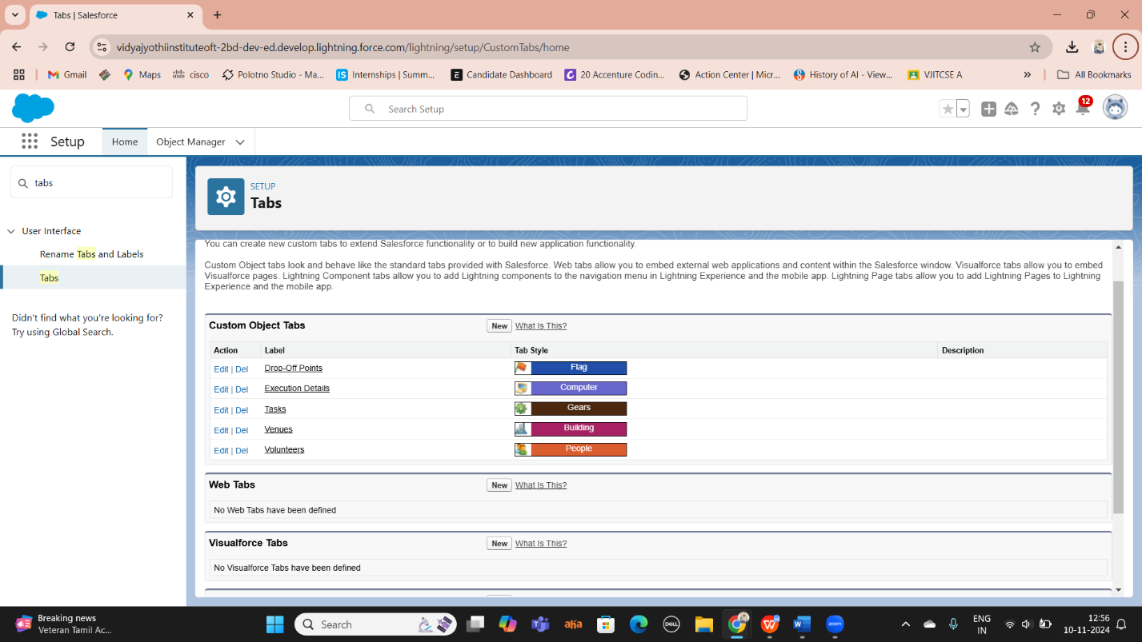

**Creation Of Fields For The Venue Object:**

1. Go to setup>> click on Object Manager >> type object name(Venue) in search bar >> click on the object.
2. Now click on “Fields & Relationships” >> New
3. Select Data type as a “Email” and Click on Next
4. Fill the Above as following:

* Field Label : Contact Email
* Field Name : Contact Email
* Click on required check box
* Click on Next >> Next >> Save and new.

**To create another fields in an object:**

1. Go to setup >> click on Object Manager >> type object name(Venue) in search bar >> click on the object.
2. Now click on “Fields & Relationships” >> New
3. Select Data type as a “Phone” and Click on Next
4. Fill the Above as following:

* Field Label : Contact Phone
* Field Name : Contact Phone
* Click on required check box
* Click on Next >> Next >> Save and new.

**To create another fields in an object:**

1. Go to setup >> click on Object Manager >> type object name(Venue) in search bar >>click on the object.
2. Now click on “Fields & Relationships” >> New
3. Select Data type as a “Geolocation” and Click on Next
4. Fill the Above as following:

* Field Label : Location
* Decimal Places : 4
* Field Name : Location
* Description : Enter the Geolocation of your Venue
* Click on Next >> Next >> Save and new.

To create another fields in an object:

1. Go to setup >> click on Object Manager >> type object name(Venue) in search bar >> click on the object.
2. Now click on “Fields & Relationships” >> New
3. Select Data type as a “Long Text Area” and Click on Next
4. Fill the Above as following:

* Field Label : Venue Location
* Field Name : Venue_Location
* Click on Next >> Next >> Save and new.

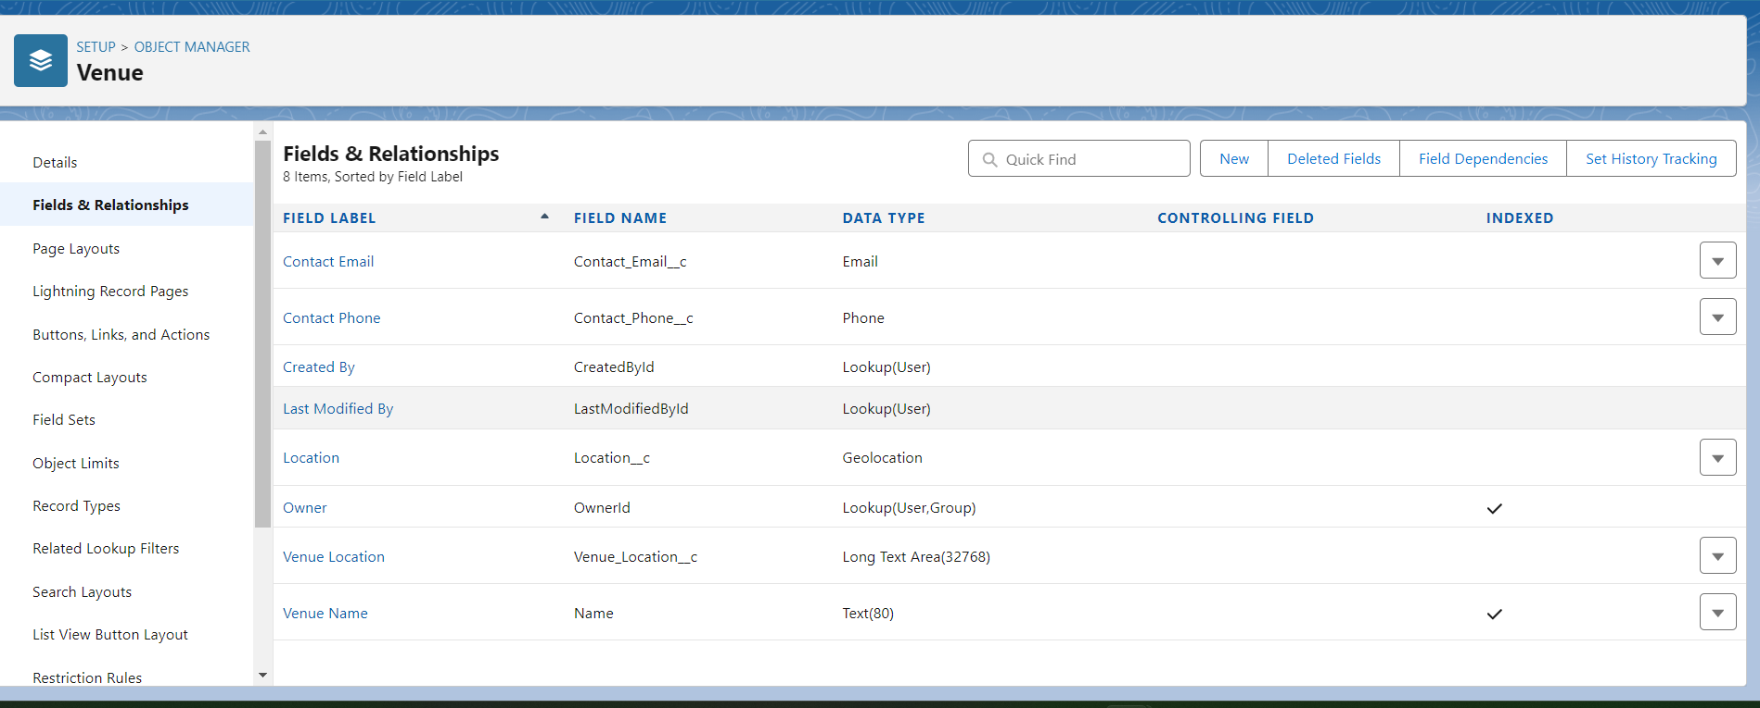

**Creation Of Fields For The Drop-Off Point Object**

1. Go to setup >> click on Object Manager >> type object name(Drop-Off point) in search bar >> click on the object.

2. Now click on “Fields & Relationships” >> New

3. Select Data type as a “Geolocation” and Click on Next

4. Fill the Above as following:

* Field Label : Location 2
* Field Name : gets auto generated
* Description : Enter the Geolocation of the Drop off Point
* Geolocation Options : select Decimal
* Decimal Places : 4
* Click on Next >> Next >> Save and new.

To create another fields in an object:

1. Go to setup >> click on Object Manager >> type object name(Drop-Off point) in search bar >> click on the object.
2. Now click on “Fields & Relationships” >> New
3. Select Data type as a “Formula” and Click on Next
4. Fill the Above as following:

* Field Label : distance calculation
* Field Name : distance_calculation
* Formula Return Type : Number
* Formula Options : DISTANCE( Location_2__c , Venue__r.Location__c , 'km')
* Click on Next >> Next >> Save and new

To create another fields in an object:

1. Go to setup >> click on Object Manager >> type object name(Drop-Off point) in search bar >> click on the object.
2. Now click on “Fields & Relationships” >> New
3. Select Data type as a “Picklist” and Click on Next
4. Fill the Above as following:

* Field Label : State
* Field Name : State
* Enter values, with each value separated by a new line :

Andhra Pradesh

Arunachal Pradesh

Assam

Bihar

Chhattisgarh

Goa

Gujarat

Haryana

Himachal Pradesh

Jharkhand

Karnataka

Kerala

Maharashtra

Madhya Pradesh

Manipur

Meghalaya

Mizoram

Nagaland

Odisha

Punjab

Rajasthan

Sikkim

Tamil Nadu

Tripura

Telangana

Uttar Pradesh

Uttarakhand

West Bengal

Andaman & Nicobar (UT)

Chandigarh (UT)

Dadra & Nagar Haveli and Daman & Diu (UT)

Delhi [National Capital Territory (NCT)]

Jammu & Kashmir (UT)

Ladakh (UT)

Lakshadweep (UT)

Puducherry (UT)

* Click on required check box
* Click on Next >> Next >> Save and new.

To create another fields in an object:

1. Go to setup >> click on Object Manager >> type object name(Task) in search bar >> click on the object.
2. Now click on “Fields & Relationships” >> New
3. Select Data type as a “Number” and Click on Next
4. Fill the Above as following:

* Field Label : Distance
* Field Name : Distance
* Length : 14
* Decimal Places : 4
* Click on required check box
* Click on Next >> Next >> Save and new.

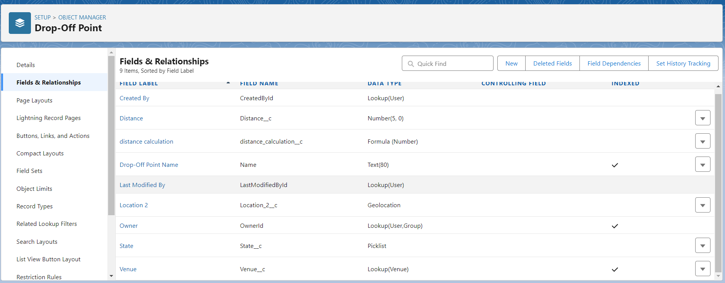

**Creation Of Fields For The Task Object:**

1.Go to setup>> click on Object Manager >> type object name(Task) in search bar >> click on the object.

2. Now click on “Fields & Relationships” >> New

3. Select Data type as a “Auto Number” and Click on Next

4. Fill the Above as following:

* Field Label : Task ID
* Display Format : TASK-{0}
* Starting Number : 1
* Field Name : gets auto generated
* Click on required check box
* Click on Next >> Next >> Save and new.

To create another fields in an object:

1. Go to setup >> click on Object Manager >> type object name(Task) in search bar >> click on the object.
2. Now click on “Fields & Relationships” >> New
3. Select Data type as a “Date” and Click on Next
4. Fill the Above as following:

* Field Label : Date
* Field Name : Date
* Click on required check box
* Click on Next >> Next >> Save and new.

To create another fields in an object:

1. Go to setup >> click on Object Manager >> type object name(Task) in search bar >> click on the object.
2. Now click on “Fields & Relationships” >> New
3. Select Data type as a “Picklist (Multi-Select)” and Click on Next
4. Fill the Above as following:

* Field Label : Food Category
* Field Name : Food Category
* Enter values, with each value separated by a new line :

Veg

Non-Veg

Salad

Snack

* Click on required check box
* Click on Next >> Next >> Save and new.

To create another fields in an object:

1. Go to setup >> click on Object Manager >> type object name(Task) in search bar >> click on the object.
2. Now click on “Fields & Relationships” >> New
3. Select Data type as a “Number” and Click on Next
4. Fill the Above as following:

* Field Label : Number of People Served
* Field Name : Number_of_People_Served
* Click on required check box
* Click on Next >> Next >> Save and new.

To create another fields in an object:

1. Go to setup >> click on Object Manager >> type object name(Task) in search bar >> click on the object.
2. Now click on “Fields & Relationships” >> New
3. Select Data type as a “Text” and Click on Next
4. Fill the Above as following:

* Field Label : Name of the Person
* Field Name : Name_of_the_Person
* Click on Next >> Next >> Save and new.

To create another fields in an object:

1. Go to setup>> click on Object Manager >> type object name(Task) in search bar >> click on the object.
2. Now click on “Fields & Relationships” >> New
3. Select Data type as a “Phone” and Click on Next
4. Fill the Above as following:

* Field Label : Phone
* Field Name : Phone
* Click on Next >> Next>> Save and new.

To create another fields in an object:

1. Go to setup >> click on Object Manager >> type object name(Task) in search bar >> click on the object.
2. Now click on “Fields & Relationships” >> New
3. Select Data type as a “Pick List” and Click on Next
4. Fill the Above as following:

* Field Label : Rating
* Field Name : Rating
* Enter values, with each value separated by a new line :

1

2

3

4

5

* Click on Next >> Next >> Save and new.

To create another fields in an object:

1. Go to setup >> click on Object Manager >> type object name(Task) in search bar >> click on the object.
2. Now click on “Fields & Relationships” >> New
3. Select Data type as a “Long Text Area” and Click on Next
4. Fill the Above as following:
5. Field Label : Feedback

* Field Name : Feedback
* Click on Next >> Next >> Save and new.

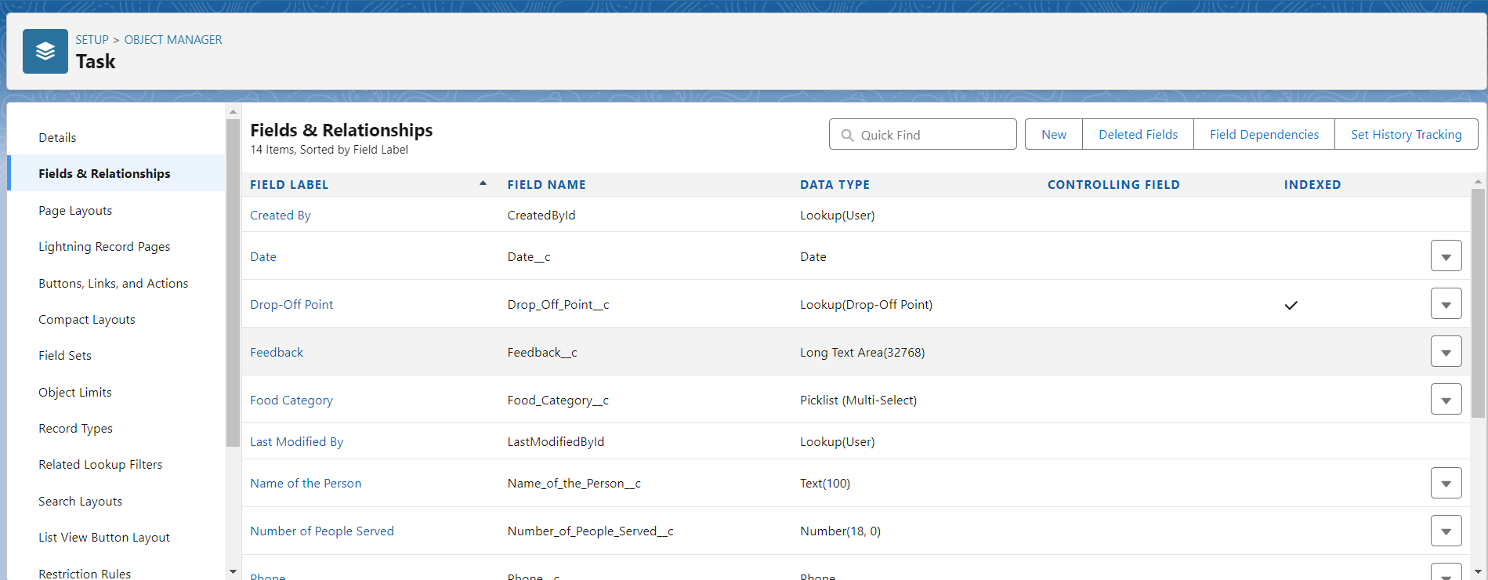

**Creation Of Fields For The Volunteer Object**

1. Go to setup >> click on Object Manager >> type object name(Volunteer) in search bar >> click on the object.

2. Now click on “Fields & Relationships” >> New

3. Select Data type as a “Auto Number” and Click on Next

4. Fill the Above as following:

* Field Label : Volunteer ID
* Field Name : gets auto generated
* Click on required check box
* Click on Next >> Next >> Save and new.
* Click on Next >> Next >> Save and new.

To create another fields in an object:

1. Go to setup >> click on Object Manager >> type object name(Volunteer) in search bar >> click on the object.
2. Now click on “Fields & Relationships” >> New
3. Select Data type as a “Picklist” and Click on Next
4. Fill the Above as following:

* Field Label : Gender
* Field Name : Gender
* Enter values, with each value separated by a new line :

Female

Male

* Click on Next >> Next >> Save and new.

To create another fields in an object:

1. Go to setup >> click on Object Manager >> type object name(Volunteer) in search bar >> click on the object.
2. Now click on “Fields & Relationships” >> New
3. Select Data type as a “Date” and Click on Next
4. Fill the Above as following:

* Field Label : Available On
* Field Name : Available On
* Click on required check box
* Click on Next >> Next >> Save and new.

To create another fields in an object:

1. Go to setup >> click on Object Manager >> type object name(Volunteer) in search bar >> click on the object.
2. Now click on “Fields & Relationships” >> New
3. Select Data type as a “Number” and Click on Next
4. Fill the Above as following:

* Field Label : Age
* Field Name : Age
* Click on required check box
* Click on Next >> Next>> Save and new.

To create another fields in an object:

1. Go to setup >> click on Object Manager >> type object name(Volunteer) in search bar >> click on the object.
2. Now click on “Fields & Relationships” >> New
3. Select Data type as a “Email” and Click on Next
4. Fill the Above as following:

* Field Label : Email
* Field Name : Email
* Click on required check box
* Click on Next>> Next >> Save and new.

To create another fields in an object:

1. Go to setup >> click on Object Manager >> type object name(Volunteer) in search bar >> click on the object.
2. Now click on “Fields & Relationships” >> New
3. Select Data type as a “Number” and Click on Next
4. Fill the Above as following:

* Field Label : Contact Number
* Field Name : Contact_Number
* Click on required check box
* Click on Next >> Next >> Save and new.

To create another fields in an object:

1. Go to setup >> click on Object Manager >> type object name(Volunteer) in search bar >> click on the object.
2. Now click on “Fields & Relationships” >> New
3. Select Data type as a “Text Area (Long)” and Click on Next
4. Fill the Above as following:

* Field Label : Address
* Field Name : Address
* Click on Next >> Next >> Save and new.

To create another fields in an object:

1. Go to setup >> click on Object Manager >> type object name(Volunteer) in search bar >> click on the object.
2. Now click on “Fields & Relationships” >> New
3. Select Data type as a “Date” and Click on Next
4. Fill the Above as following:

* Field Label : Date of Birth
* Field Name : Date_of_Birth
* Click on Next >> Next >> Save and new.

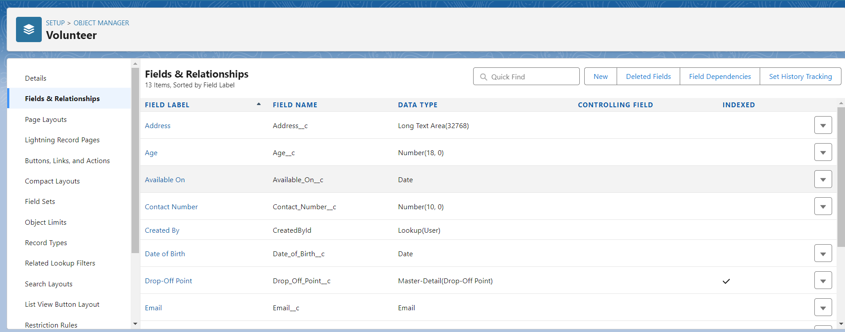

**Creation Of Fields For The Execution Details Object**

1.Go to setup >> click on Object Manager >> type object name(Volunteer) in search bar >> click on the object.

2. Now click on “Fields & Relationships” >> New

3. Select Data type as a “Auto Number” and Click on Next

4. Fill the Above as following:

* Field Label : Execution ID
* Field Name : gets auto generated
* Click on required check box
* Click on Next >> Next >> Save and new.

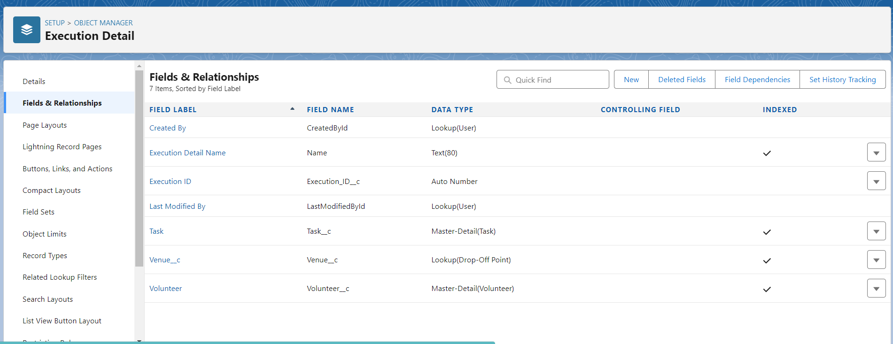

**FLOWS:**

**Create Flow To Create A Record In Venue Object**

1. Go to setup >> type Flow in quick find box >> Click on the Flow and Select the New Flow.
2. Select the Screen flow. Click on create.
3. Click on the ‘+’ icon in between start and end, and click on screen element.
4. Under the Screen Properties:

Label : Venue Details

API Name : Venue_Details

1. Now lets add components in this flow. Click on Text Component and name it as:
2. Label : Venue Name
3. API Name : Venue_Name
4. Click on Email Component and name it as:
5. Label : Email
6. API Name : Contact_Email
7. Click on Phone Component and name it as:
8. Label : Phone
9. API Name : Contact_Phone
10. Click on Text Component and name it as:
11. Label : Venue Location
12. API Name : Venue_Location
13. Click on Number Component and name it as:
14. Label : Latitude
15. API Name : Latitude
16. Click on Number Component and name it as:
17. Label : longitude
18. API Name : longitude
19. Next click on Done. This would like below
20. Click on the ‘+’ icon in between Venue details and end, and click on create record element.
21. Now label it as

Label : Create Venue Record

API Name : Create_Venue_Record

How Many Records to Create : One

How to Set the Record Fields : Use separate resources, and literal values

Object : Venue

Set Field Values for the Venue : Click on ‘Add Field’ 5 times

Field : Value = Contact_Email__c : {!Contact_Email.value}

Field : Value = Contact_Phone__c : {!Contact_Phone.value}

Field : Value = Name : {!Venue_Name}

Field : Value = Venue_Location__c : {!location}

Field : Value = Location__Latitude__s : {!latitude}

Field : Value = Location__Longitude__s : {!longitude}

1. This would look like:
2. Click on Save as:

Flow Label : Venue Form

Flow API Name : Venue_Form

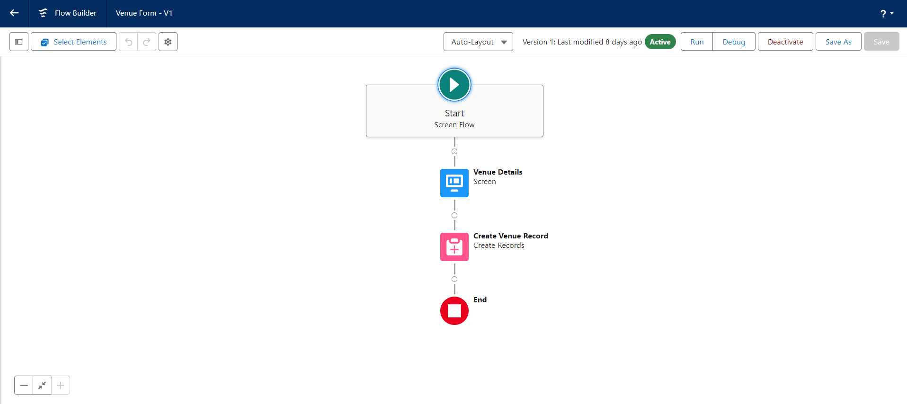

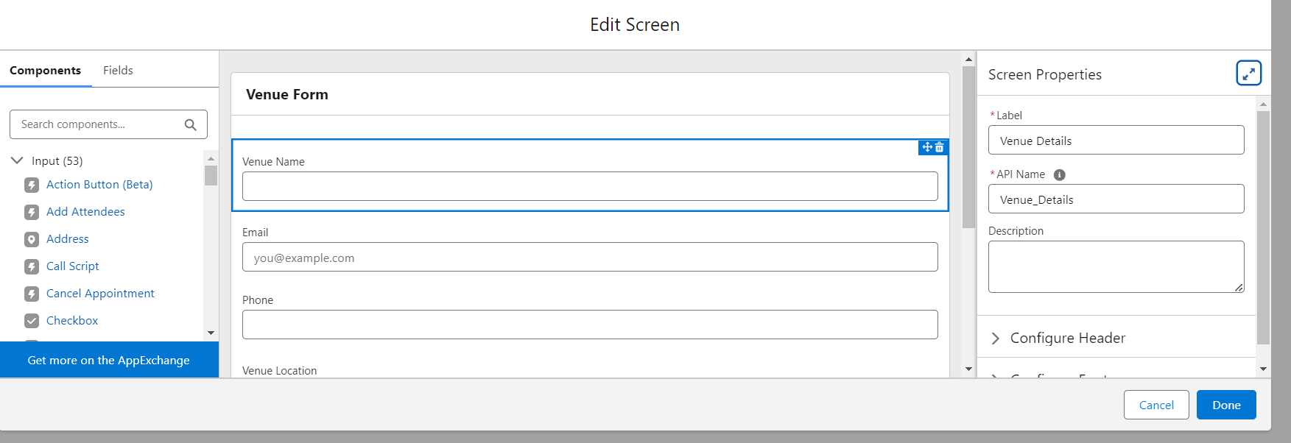

**TRIGGER:**

**Create A Trigger**

1. Log into the trailhead account, navigate to the gear icon in the top right corner.
2. Click on developer console and you will be navigated to a new console window.
3. Click on the File menu in the toolbar, and click on new >> Trigger.
4. Enter the trigger name and the object to be triggered.Enter Name : DropOffTriggersObject: Drop-Off Point.Click on Submit.

# Testing and Validation

Describe the approach to testing:

* Unit Testing (Apex Classes, Triggers).

User Interface Testing

**TRIGGER CODE:**.

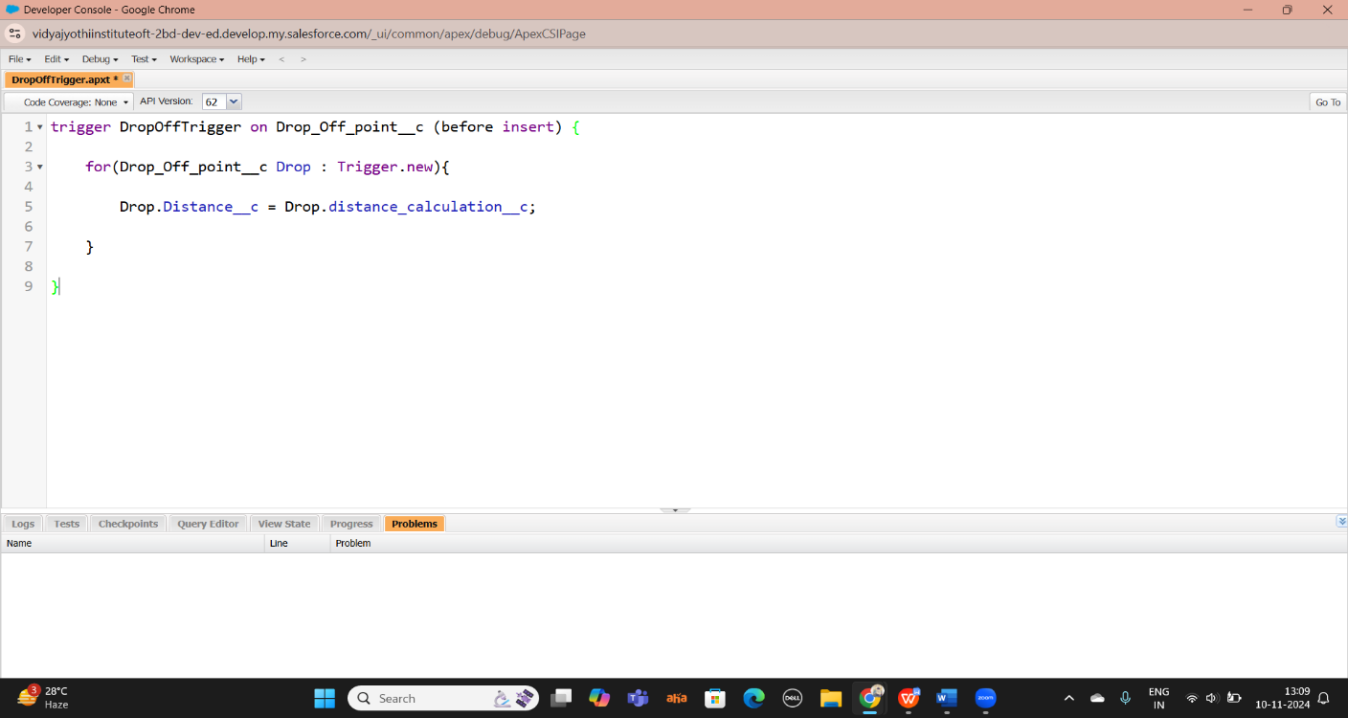

**Profiles:**

1. Go to setup page >> type Profiles in Quick Find bar >> click on Profiles >> click on ‘S’
2. Click on Clone beside Standard Platform User.
3. Under Clone Profile:

Profile Name : NGOs Profile

Then click on Save

Creation Of Users:

In this Project we consider them as NGO’s.

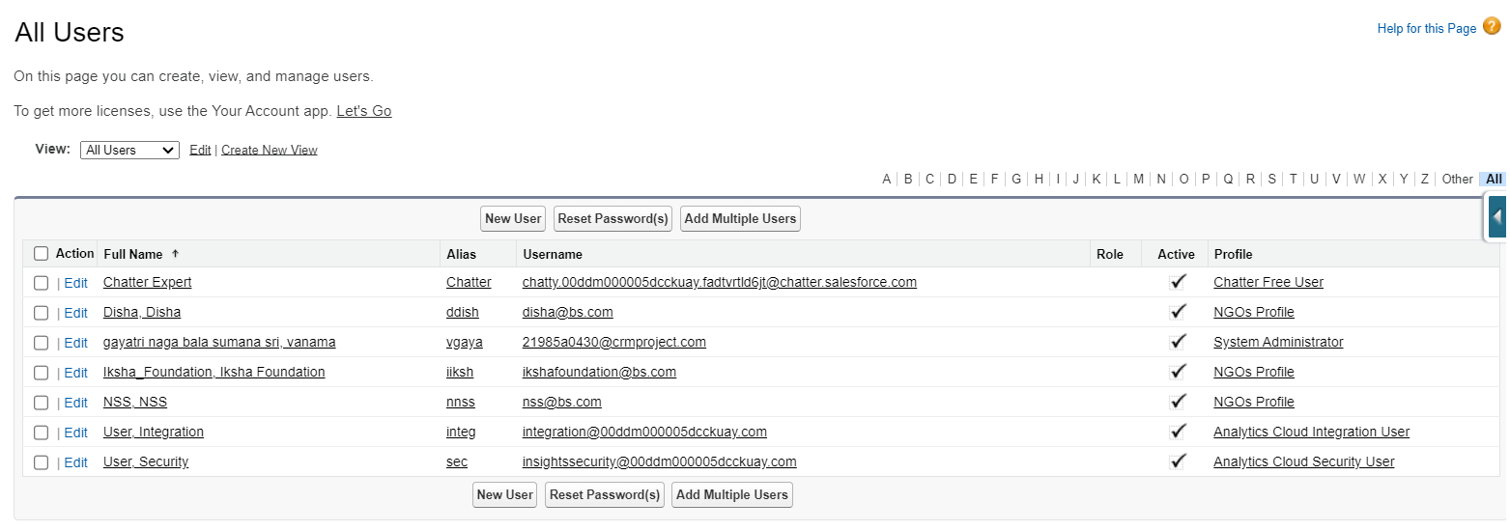

**Creation Of Public Group 1**

1. Go to setup page >> type Public Groups in Quick Find bar >> click on Public Groups >> click on New.
2. Under Group Information:

Label : Iksha

Group Name : Iksha

Grant Access Using Hierarchies : Check

1. In Search, Select Users.
2. In Selected Members Add Iksha Foundation and System Administrator

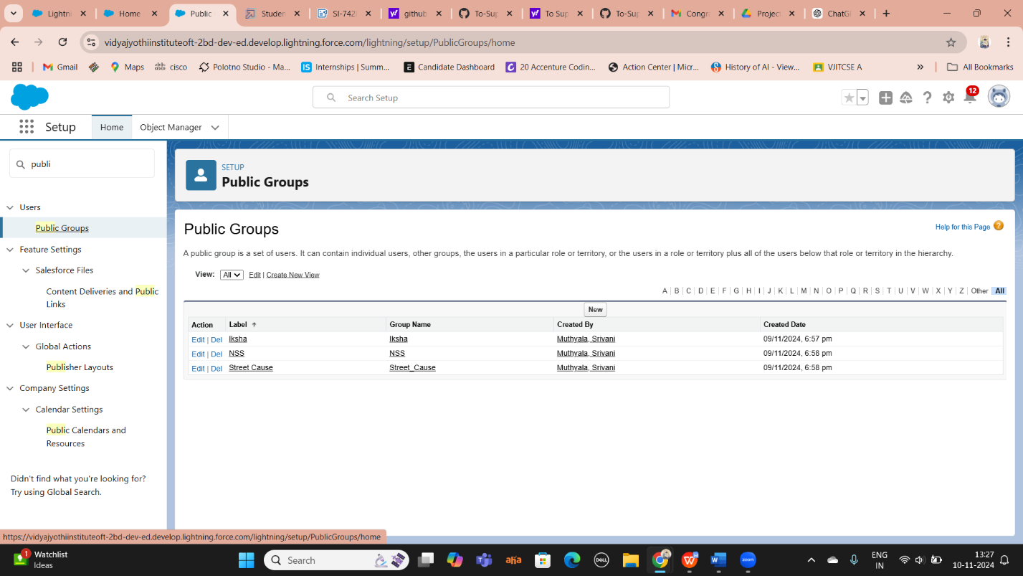

5.create another two public groups as disha and nss.

**Creation Of Report Types**

1. Go to setup page >> type Report Types in Quick Find bar >> click on Report Types >> click on Continue >> Click on New Custom Report Type.
2. In Define the Custom Report Type:

Primary Object : Select Venues

Report Type Label : Venue with DropOff with Volunteer

Report Type Name : Venue_with_DropOff_with_Volunteer

Description : Venue with DropOff with Volunteer

Store in Category : Select Other Reports

Deployment Status : Deployed

1. Click on Next
2. Near Click to relate another Object Select Drop-Off Points.
3. And also select "A" records may or may not have related "B" records.
4. Now again Near Click to relate another Object Select Volunteers.
5. Now click on Save.

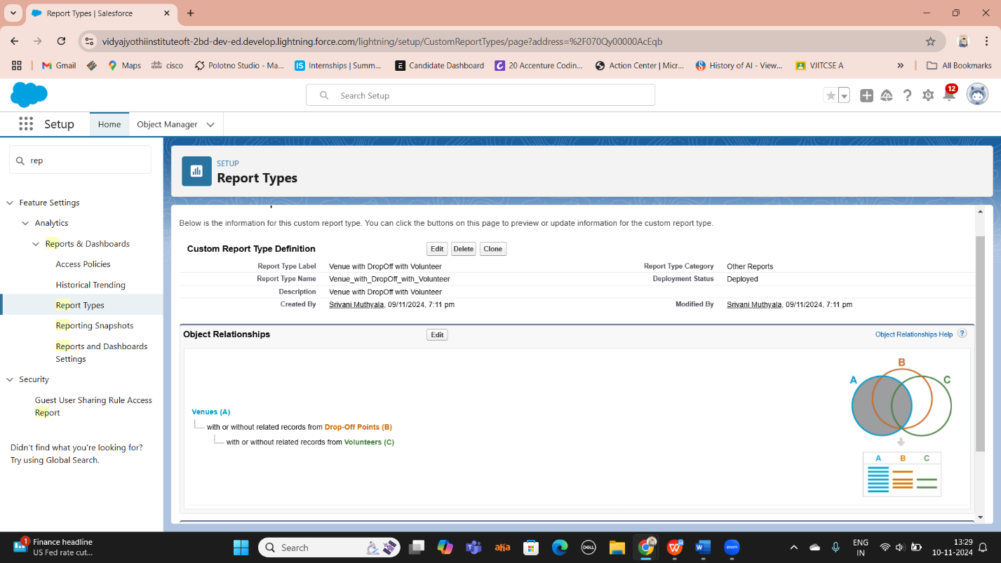

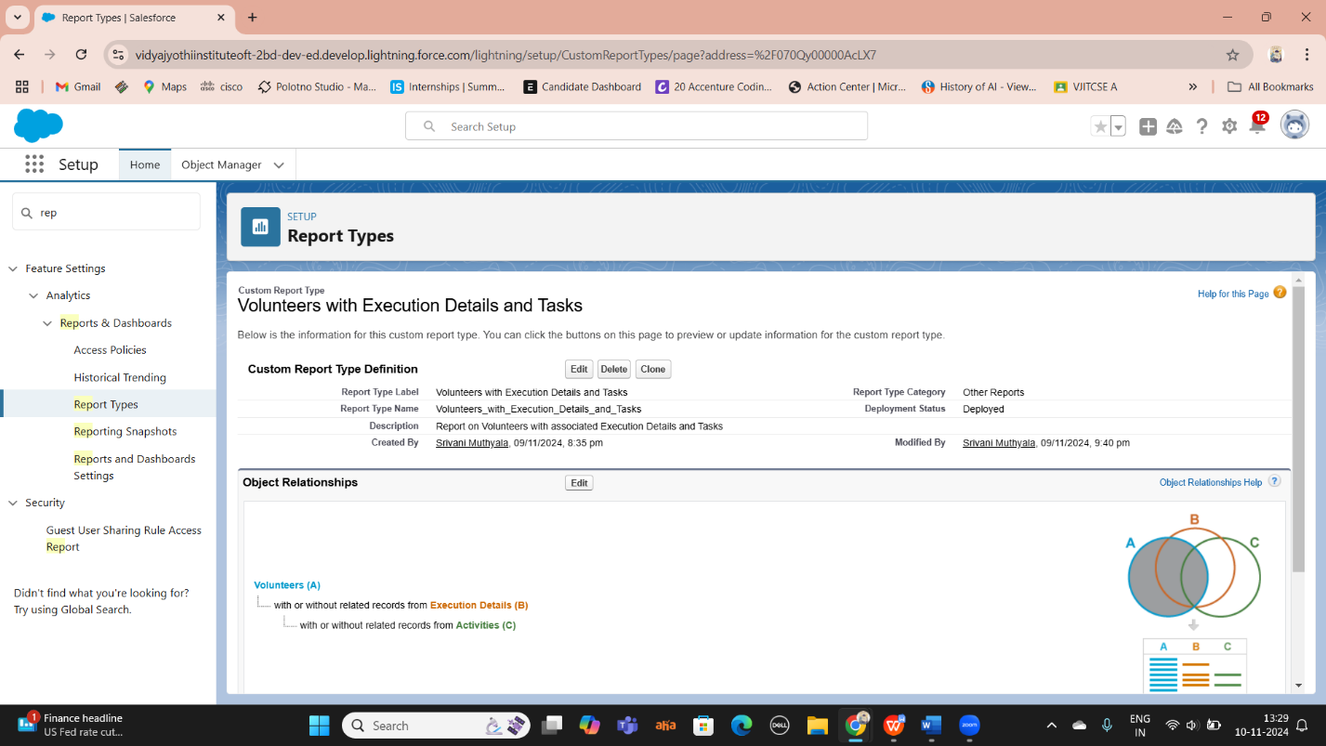

**Creation Of Report On Venue With DropOff With Volunter:**

1. Go to the app(FoodConnect) >> click on the reports tab
2. Click on New Folder.

Folder Label : Custom Reports

Folder Unique Name : CustomReports

1. Open Custom Reports and click on New Report
2. Select Report Type : Venue with DropOff with Volunteer
3. Then click on Start Report.
4. In GROUP ROWS : Add Volunteer Name
5. In Columns : Add Venue Name, Drop-Off point Name, Distance.

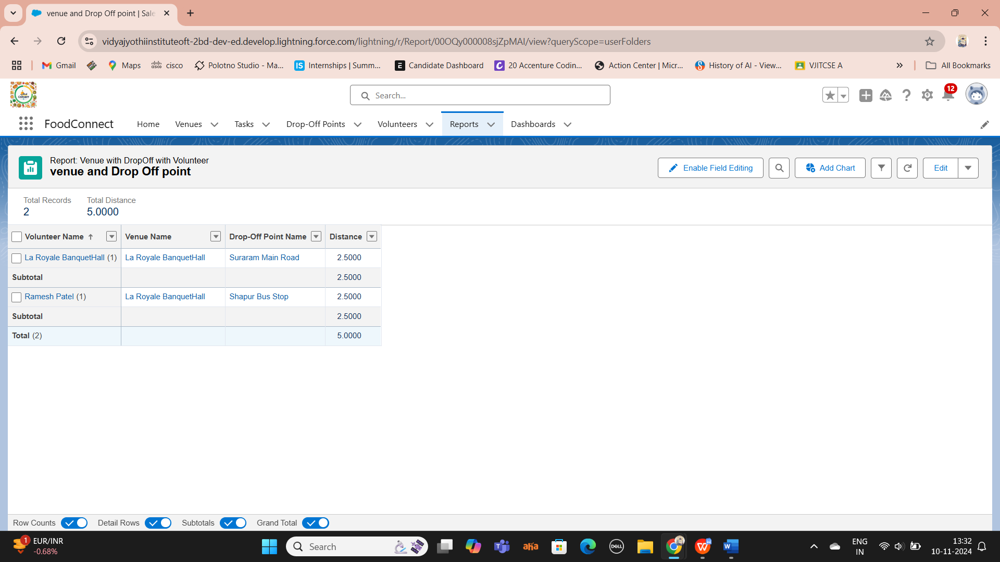

1. Now click on Save & Run.
2. Give Label as :
3. Report Name : venue and Drop Off point
4. Report Unique Name : Auto Populated
5. Click on Select Folder and select Custom Report, then click on Save.

**Creation Of Report On Volunteers With Execution Details And Tasks**

1. Go to the app(FoodConnect) >> click on the reports tab
2. Click on Custom Reports Folder and click on New Report
3. Select Report Type : Volunteers with Execution Details and Tasks.
4. Then click on Start Report.
5. In GROUP ROWS : Volunteer ID
6. In Columns : Add Volunteer : Volunteer Name, Task : Task Name, Execution Detail : Execution Detail Name, Volunteer: Owner Name, Task: Date, Task : Rating.

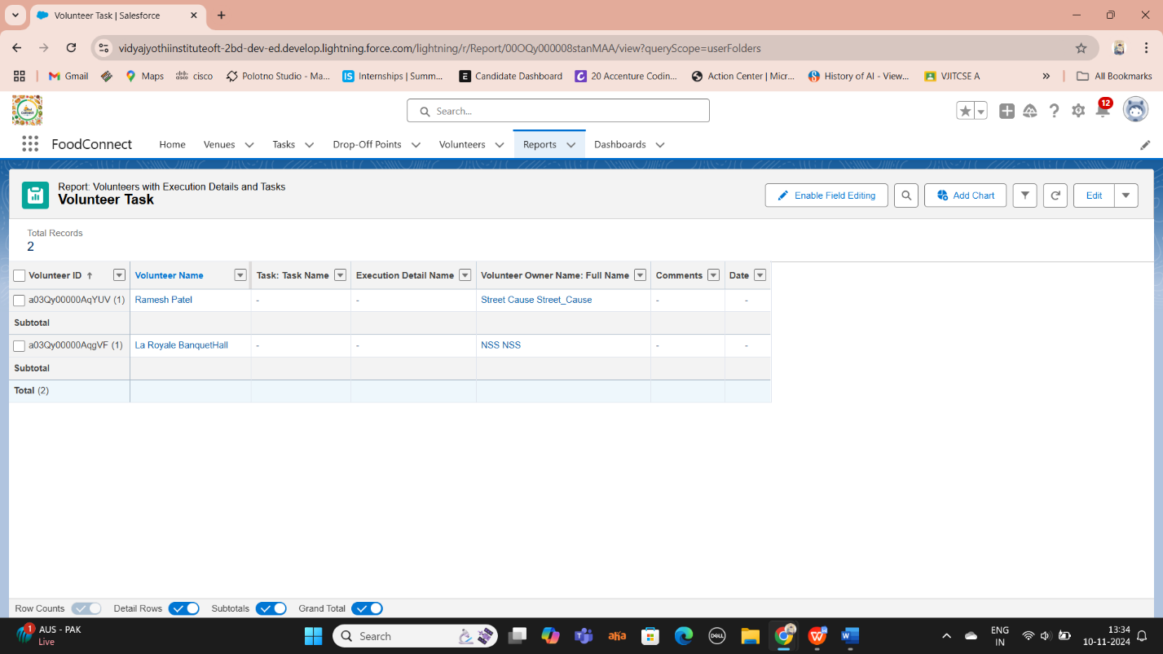

**DASHBOARDS:**

**Adding Venue And Drop Off Point Report To The Dashboard**

1. Go to the app(FoodConnect) >> click on the Dashboards tab.
2. Click on New Folder.
3. Folder Label : Custom Dashboards
4. Folder Unique Name : Auto Populated
5. Open Custom Dashboards and click on New Dashboards
6. Name : Organization Details
7. Click on Widget and select Chart or Table
8. In Select Report : Select venue and Drop Off point Report.
9. Then click on select
10. In Add Component:
11. Display As : Select Lightning Table
12. Component Theme : Select Dark (Optional).
13. Now click on save.

**Adding Volunteer Task Report To The Dashboard**

1. Click on Widget and select Chart or Table
2. In Select Report : Select Volunteer Task Report.
3. Then click on select
4. In Add Component:

Display As : Select Line Chart

Component Theme : Select Dark (Optional).

Now click on save.

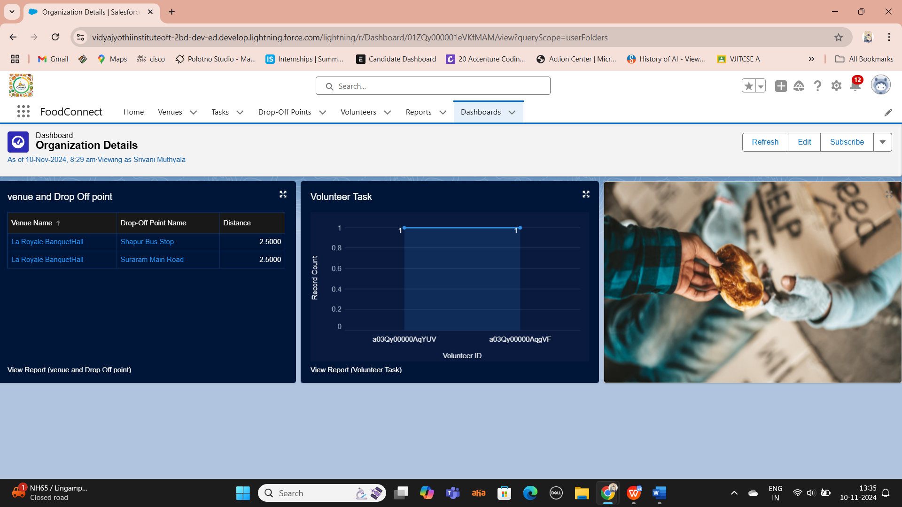

**SHARING RULES:**

**Creation Of Sharing Rules**

1. Go to setup >> type Sharing Settings in quick find box >> Click on the Sharing Settings.
2. Scroll down and find Drop-Off point Sharing Rules.
3. Click on new near Drop-Off point Sharing Rules and Name it as:

Label : Rule 1

Rule Name : Rule_1

1. Select your rule type : Select Based on criteria.
2. Select which records to be shared:
3. Field : Operator : Value = Distance : less than : 15
4. Select the users to share with : Near Share With
5. Public Groups : Iksha
6. Click on Save.
7. Click on new near Drop-Off point Sharing Rules and Name it as:
8. Label : Rule 2
9. Rule Name : Rule_2
10. Select your rule type : Select Based on criteria.
11. Select which records to be shared:
12. Field : Operator : Value = Distance : greater than : 15
13. Field : Operator : Value = Distance : less or equal : 30
14. Select the users to share with : Near Share With
15. Public Groups : NSS
16. Click on Save.
17. Click on new near Drop-Off point Sharing Rules and Name it as:
18. Label : Rule 3
19. Rule Name : Rule_3
20. Select your rule type : Select Based on criteria.
21. Select which records to be shared:
22. Field : Operator : Value = Distance : greater than : 30
23. Field : Operator : Value = Distance : less or equal : 50
24. Select the users to share with : Near Share With
25. Public Groups : Street Cause
26. Click on Save.

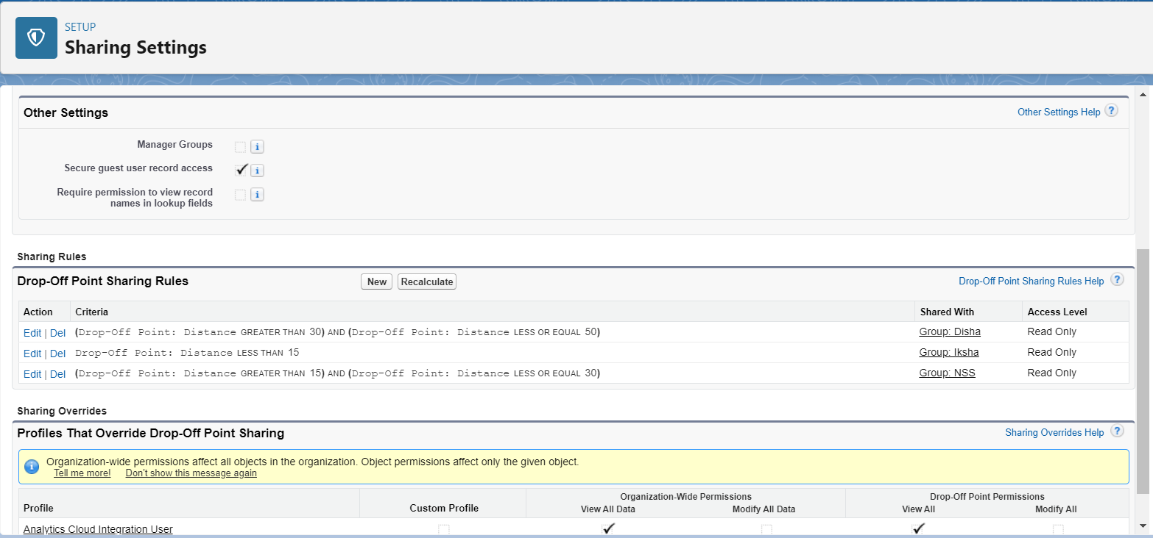

**HOME PAGE:**

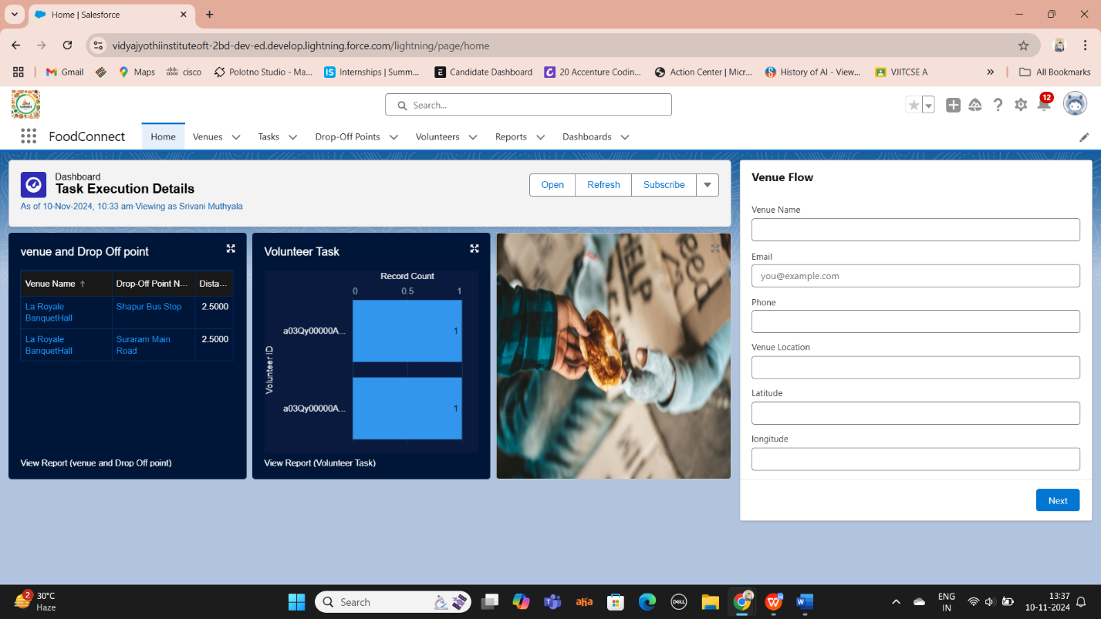

# Key Scenarios Addressed by Salesforce in the Implementation Project.



# Efficient Task Assignment to Volunteers

* **Scenario**: When new food collection tasks are created, the system automatically assigns tasks to volunteers based on proximity, availability, and capacity.
* **How Salesforce Helps**: Using Salesforce’s automation tools like *Flows* and *Process Builder*, the system can automatically trigger task assignments. Custom fields like volunteer location (geolocation) can be used to ensure the closest volunteers are assigned tasks, and notifications can be sent out to inform them of new tasks.

**2. Real-Time Tracking and Management of Food Donations**

* **Scenario**: Volunteers need to track food donations in real time, including the collection status, the volume of food, and the distribution status.
* **How Salesforce Helps**: Salesforce custom objects and fields allow real-time data tracking of food donations, collection status, and drop-off points. Volunteers and managers can view updates on donation status through custom dashboards and reports, providing a clear overview of all active and completed tasks.

**3. Distance-Based Sharing of Drop-Off Points**

* **Scenario**: Different public groups (e.g., *Iksha*, *NSS*, *Street Cause*) should have access to specific *Drop-Off Points* based on distance from the location.
* **How Salesforce Helps**: Salesforce’s sharing rules, specifically distance-based sharing, can be configured to control access to *Drop-Off Points*. For instance, when a drop-off point is located within a 15 km radius of a volunteer, the appropriate public group can be granted read-only access to that drop-off point.

**4. Volunteer Management and Scheduling**

* **Scenario**: Volunteers need to be managed, including their availability, task assignments, and completion status.
* **How Salesforce Helps**: Using Salesforce’s custom objects for *Volunteers*, *Tasks*, and *Food Collection Points*, managers can maintain a detailed schedule for each volunteer. Volunteers can mark their availability, accept tasks, and report back once tasks are completed. Custom reports can be created to track volunteer hours and task completion rates.

**5. Food Collection Point Status Updates**

* **Scenario**: Food collection points need to be updated in real-time regarding their availability (e.g., open, full, closed).
* **How Salesforce Helps**: Salesforce allows custom objects to track the status of food collection points. Status updates can be captured automatically or manually by volunteers or managers through Salesforce’s UI. Automation tools can notify the relevant stakeholders when a collection point status changes.

# Conclusion

**Summary of Achievements:**

The "Food Connect" initiative has made significant strides in addressing food insecurity by leveraging technology-driven solutions, with Salesforce as the core platform powering the system. Through the use of Salesforce's robust features, the project has effectively streamlined the process of collecting and redistributing leftover food to communities in need. One of the key achievements has been the automation of task assignments to volunteers, which ensures that food distribution tasks are efficiently managed based on factors such as volunteer availability and proximity. This has not only improved operational efficiency but also reduced response times in food delivery.

Furthermore, the integration of real-time data management has played a pivotal role in enhancing transparency and coordination. The system allows for real-time tracking of food donations, collection point statuses, and volunteer activities, giving managers and stakeholders a clear, up-to-date view of the entire food redistribution process. This level of visibility has contributed to better decision-making and faster action when needed.

The project has also successfully fostered stronger engagement among volunteers and donors. Through automated notifications, personalized updates, and insightful reports, the system has kept all participants informed and motivated. Donors receive feedback on the impact of their contributions, while volunteers are consistently updated about their assigned tasks, leading to higher levels of participation and long-term involvement.

Another significant achievement is the implementation of distance-based sharing rules, which ensure that drop-off points are shared with the appropriate public groups, such as *Iksha*, *NSS*, and *Street Cause*, based on proximity. This feature has optimized the food distribution network, ensuring that food reaches those in need in the most efficient manner possible.

Finally, custom reports and dashboards have enabled stakeholders to monitor the project's success in real-time, providing valuable insights into food waste reduction, the number of people served, and the overall impact on the community. The "Food Connect" project, powered by Salesforce, has not only provided a scalable and sustainable solution to combat food insecurity but also showcased the potential of technology to drive meaningful social change.